**1). Write a program to display messages on the output screen.**

**CODE 1 :**

/*write a program to display messages on the output screen */

#include <stdio.h>

int main()

{

printf("Hello,I am studying in VGEC.");

return 0;

}

**OUTPUT 1 :**

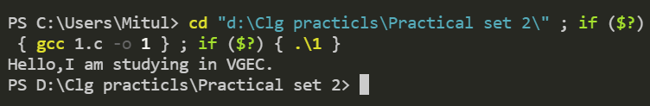

**2). Write a program to scan values for variables of different data types and print their respective values.**

**CODE 2:**

/*Write a program to scan values for variables of different data types and print their respective

values*/

#include <stdio.h>

#include<conio.h>

int main()

{

char a;

int b;

float c;

double d;

printf("Enter the value of character : ");

scanf("%c", &a);

printf("Enter the value of integer : ");

scanf("%d", &b):

printf("Enter the value of float : ");

scanf("%f", &c);

printf("Enter the value of double : ");

scanf("%lf", &d);

printf("\nThe value of character is %c", a);

printf("\nThe value of integer is %d", b);

printf("\nThe value of float is %f", c);

printf("\nThe value of double is %lf", d);

return 0;

}

**OUTPUT 2:**

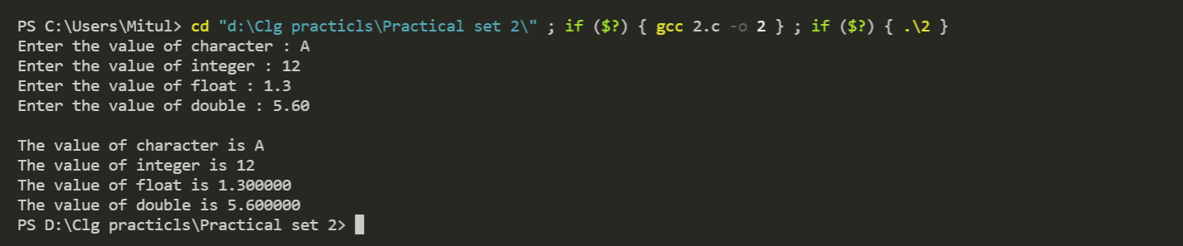

**3). Write a program that performs as calculator ( addition, multiplication, division, subtraction).**

**CODE 3:**

/*Write a program that performs as calculator ( addition, multiplication, division, subtraction). */

#include <stdio.h>

int main()

{

int a, b, c, d, f;

printf("Enter the first number : ");

scanf("%d", &a);

printf("Enter the second number : ");

scanf("%d", &b);

printf("\n\nEnter 1 for addition.");

printf("\nEnter 2 for subtraction.");

printf("\nEnter 3 for division.");

printf("\nEnter 4 for multiplication.\n");

scanf("%d", &c);

If (c == 1)

printf("\nAddition of entered number is %d", a + b);

else if (c == 2)

printf("\nSubstraction of entered number is %d", a - b);

else if (c == 3)

printf("\nDivision of entered number is %d", a / b);

else if (c == 4)

printf("\nMultiplication of entered number is %d", a * b);

else

printf("\nYou entered wrong number");

return 0;

}

**OUTPUT 3:**

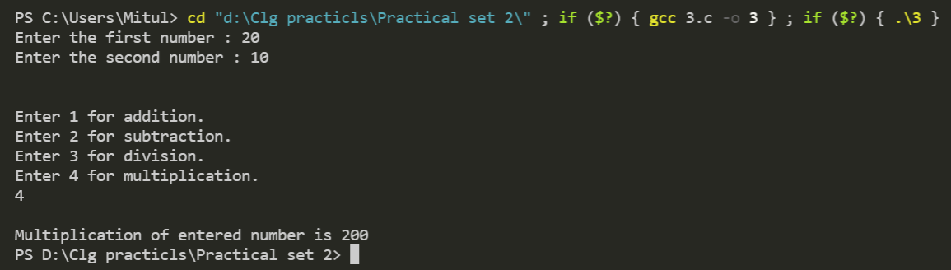

**4). Write a program to find area of triangle(a=h*b*.5)**

**a = area h = height b = base.**

**CODE 4:**

/*Write a program to find area of triangle(a=h*b*.5) a = area, h = height, b = base*/

#include<stdio.h>

int main()

{

int h,b;

float a;

printf("Enter The Height Of The Triangle : ");

scanf("%d",&h);

printf("Enter The Base Of The Triangle : ");

scanf("%d",&b);

a=h*b*.5;

printf("The Area Of The Triangle Is %.2f",a);

return 0;

}

**OUTPUT 4:**

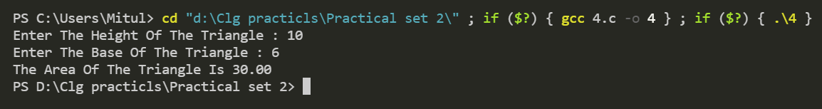

**5). Write a program to calculate simple interest (i = (p*r*n)/100 ) i = Simple interest p = Principal amount r = Rate of interest n = Number of years.**

**CODE 5:**

/*Write a program to calculate simple interest (i = (p*r*n)/100 )

i = Simple interest p = Principal amount r = Rate of interest n = Number of years*/

#include<stdio.h>

#include<conio.h>

int main()

{

float p,r,n,i;

printf("Enter The Principal Amount : ");

scanf("%f",&p);

printf("Enter The Rate Of Interest : ");

scanf("%f",&r);

printf("Enter The Number Of Years : ");

scanf("%f",&n);

i=(p*r*n)/100;

printf("The Simple Interest Of The Entered Details Is %.3f.",i);

return 0;

}

**OUTPUT 5:**

